I found a bug in Modbus Slave. First time I think it is my fault that the program receives an incorrect data package. When my program “calibrate pb04” is master and Modbus Slave is a simulator for pb04 device with local IP 127.0.0.1. The problem is software Modbus Slave can’t receive the data package for my program. But I found the bug when I compare the sending data and receive with Wireshark.

This the picture shows my program send a data package pass through port 52799 to port 501 (the Modbus Slave port). My data is “00 3f 00 00 00 02 01 10 05 01 00 02 04 00 01 00 01 “ and it is success on sending process.

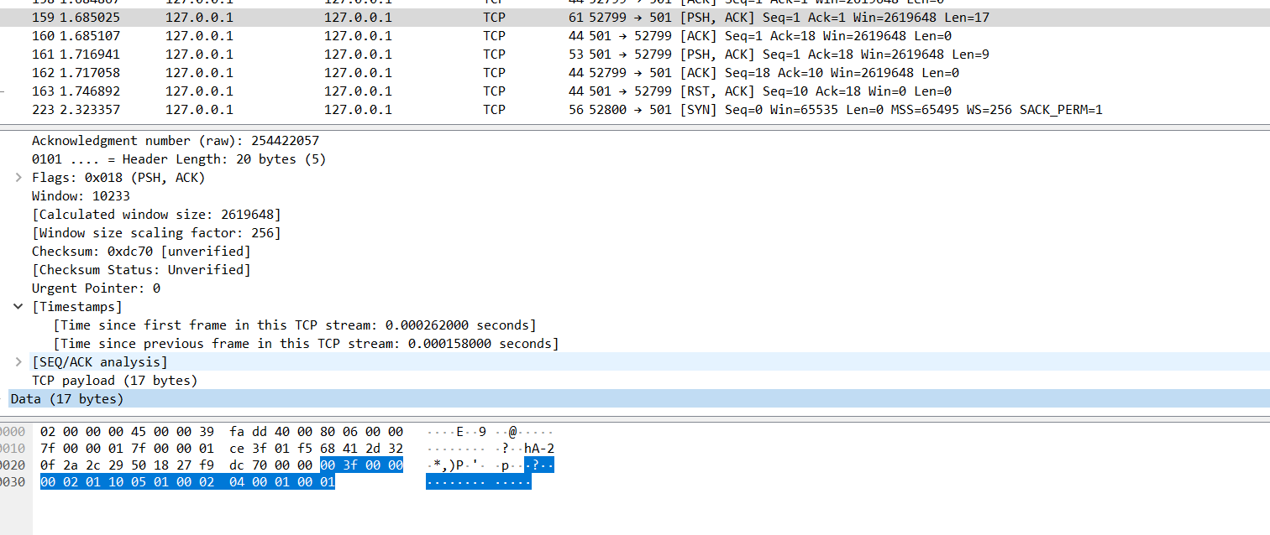

This picture shows Modbus Slave can receive my data only half of it (“00 3f 00 00 00 02 01 10”). So Modbus Slave think it’s wrong command and reply exception respond.

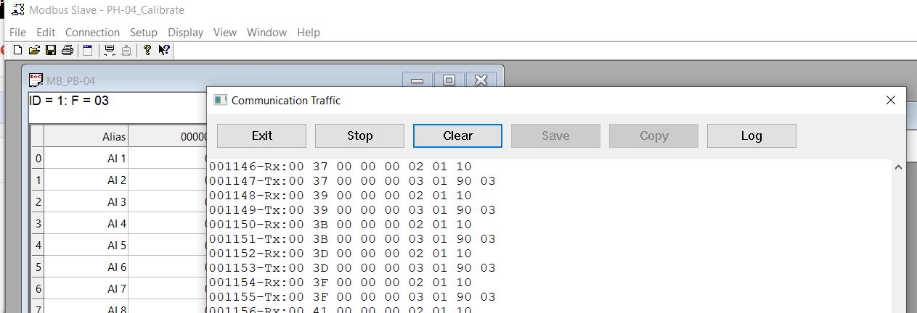

In other hand, my program calibrate pb04 can communicate with hardware correctly.